**ERD (Entity Relationship Diagram)**

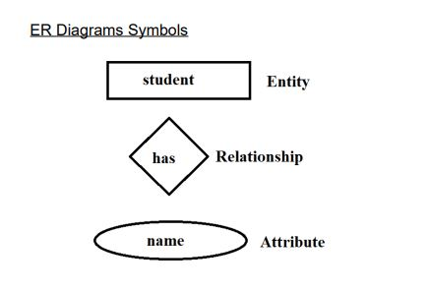

**Entity types**

E.g. Employee, Student, Car, House, Bank Account

**List of common entity types**

People: humans who carry out some function Employees, students, customers

Things: tangible physical objects Equipments, products, buildings

Organizations Teams, suppliers, departments

**Attribute**

An attribute a characteristic or property of an entity. Attributes provide specific

information about the entities in the database.

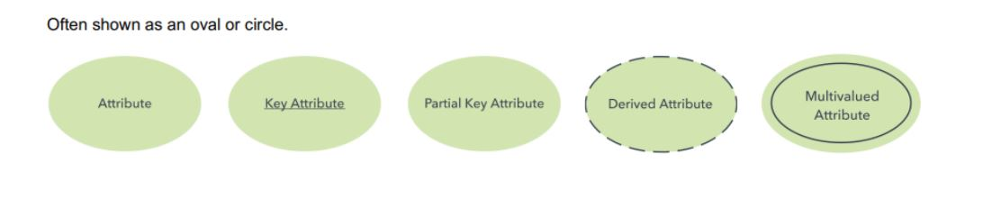

**Relationship**

A relationship is an association among several entities. There are three types of relationships.

1) One to One

2) One to Many | Many to One

3) Many to Many

